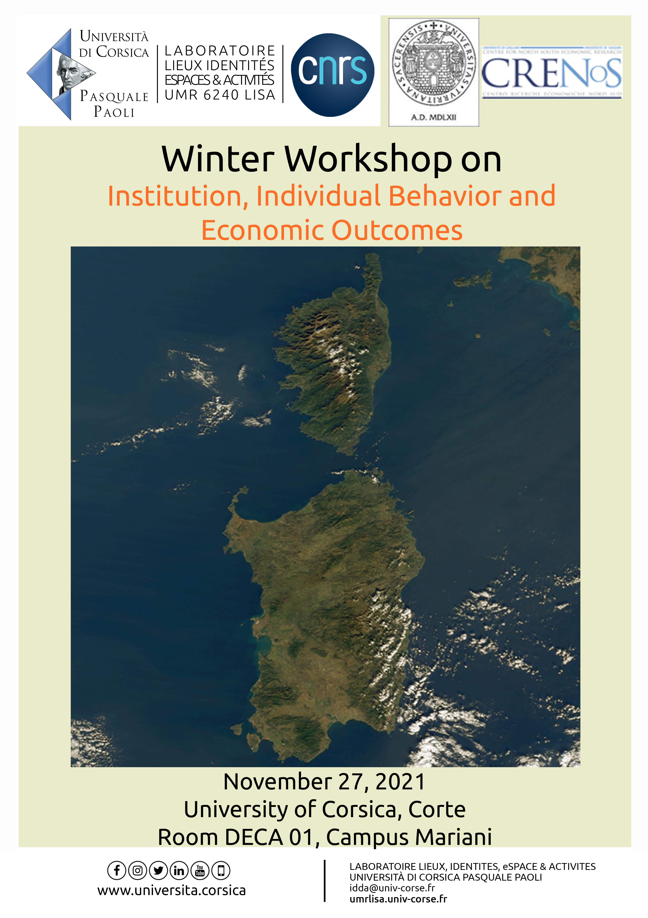

The IBEO winter workshop will take place in Corte on 27 November 2021, organized by the UMR 6240 LISA of the University of Corsica with the collaboration of CRENoS (University of Sassari and University of Cagliari, Sardinia).
The scope of the event is to give participants the opportunity to present their work in progress to an audience of peers with homogeneous research interests and get valuable feedback to improve their ongoing research.
The workshop is organised as a round table discussion in which, through the conversation of economists from different backgrounds, it will be possible to create a roadmap towards deepening current and future research and building partnerships.
This workshop will be structured around topics related to public policies and indicators for well-being and sustainable development.

Access only on presentation of a Green Pass

SCIENTIFIC COMMITEE

Claudio DETOTTO (University of Corsica) – Davide FIASCHI (University of Pisa) - Dominique PRUNETTI (University of Corsica) – Gianfranco ATZENI (University of Sassari) – Marco VANNINI (University of Sassari)

LOCAL ORGANIZING COMMITTEE

Claudio DETOTTO – University of Corsica
Corinne IDDA – University of Corsica
Dominique PRUNETTI – University of Corsica

CONTACT

Corinne IDDA
UMR CNRS 6240 LISA - University of Corsica
+33 (0)4 95 20 20 64 - idda@univ-corse.fr

